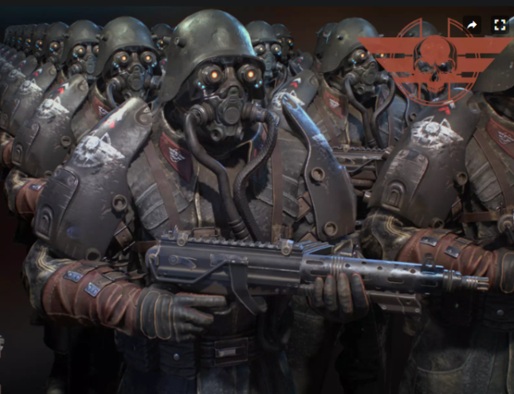ARMA X

Narrative Design

**Daniel Bellido Chueco**

**Games & Media Creation Process**

**February 2023**



Table of Contents

1. DRAMATIS PERSONAE 3

2. PLOT 3

3. THE HERO’S JOURNEY 5

4. CUTSCENES IDEAS 6

5. OBJECTIVES & MISSIONS IN GAME 6

6. SUBPLOT IDEAS 7

## DRAMATIS PERSONAE

|  |  |
| --- | --- |
| Role | Name |
| Hero | Yair (Johann Scholl) |
| Mentor | Colonel Harris |
| Villain | Grendel Waltz |
| Enemy | Soldier 1 |
| Enemy | Soldier 2 |

## PLOT

**Prologue**

In a dystopian reality where Nazi Germany emerges victorious in the D-Day Battle of World War II, they successfully conquer Europe, the United Kingdom, and a portion of the Soviet Union. After years of warfare and casualties, the involved nations come to a truce where the Third Reich, alongside its puppet governments, establishes itself as a dominant European empire. Meanwhile, the United States successfully defeats Japan and eradicates Nazi influence from the Pacific. Despite agreeing to a ceasefire, strained relations persist between the United States, the Soviet Union, China, and Nazi Europe. This cold war atmosphere is exacerbated by the presence of nuclear weapons worldwide, creating a looming threat of nuclear conflict.



**Act I: Infiltration**

The first act opens with the introduction of the main character, a special SIS agent who is tasked with infiltrating a Nazi military base located in Iceland. The mission is to verify if the Nazis have deployed nuclear weapons in order to threaten the United States and Canada and obtain secret documentation. The agent is given minimal information about the base, its location, and the SS officer that they need to eliminate. The agent must rely on their training, cunning, and wit to carry out the mission.

The act is filled with tension and suspense as the agent faces numerous challenges and obstacles in their attempt to infiltrate the base. The agent encounters a large number of Nazi soldiers, but he uses his skills to remain undetected and reach their objective. The act ends with the agent successfully infiltrating the base, but his mission is far from over as they must now find the nuclear weapons, the secret documentation and eliminate the SS commander.

**Act II: Retrieval and Elimination**

The second act focuses on the agent's attempt to find the Nukes, eliminate the SS commander and retrieve the secret documentation. The agent must navigate the base, avoiding detection, and find the information that will determine the fate of the world. The act is filled with dangerous encounters, close calls, and unexpected twists as the agent is pursued by the Nazi soldiers and the SS officer becomes aware of their presence. The agent must use all his skills and resources to carry out the mission and get out of the base alive. After killing the officer, he finds a plane in an old hangar and escapes from the base having a final encounter with enemy soldiers.

**Act III: Conclusion**

The final act reveals the outcome of the mission. The agent successfully retrieves the secret documentation and eliminates the SS officer. The information reveals that the Nazis not only have deployed nuclear weapons but there is something else known as the Arma X and the United States and Canada are in grave danger. The Arma X is a secret weapon capable of emitting a powerful electromagnetic pulse (EMP) that disables all electronic devices within a given radius, including aircraft, missiles, and defence systems. The agent's success is celebrated, but the future remains uncertain as the tensions between the Nazi Europe and the other world powers continue to escalate. The story ends with a sense of foreboding, leaving the player wondering what will happen next and if the world will ever be at peace.

## THE HERO’S JOURNEY

In this story, the main character, the special SIS agent, codename Yair, goes through the following stages of the hero's journey:

* **The Call to Adventure:** Yair is tasked with infiltrating a Nazi military base located in Iceland to verify if the Nazis have deployed nuclear weapons and obtain secret documentation. This marks the start of the hero's journey and the call to adventure.
* **Refusal of the Call:** Yair may initially hesitate or question the mission, but he eventually accepts it and begins his journey.
* **Meeting with the Mentor:** The agent receives information about the base and his objective, he relies on his training and skills obtained in the past by his instructor, Colonel Harris, to carry out the mission. In this sense, the agent's mentor is the Colonel who was his instructor and is in contact with him via radio during the mission.
* **Crossing the Threshold:** The agent infiltrates the Nazi military base and begins the dangerous task of retrieving the secret documentation and eliminating the SS officer. This marks the crossing of the threshold into the unknown and dangerous world of the base.
* **Tests, Allies, and Enemies:** Yair faces numerous challenges and obstacles as he navigates the base, including fierce resistance from Nazi soldiers and the pursuit of the SS officer.
* **Approach to the Innermost Cave:** Yair reaches his objective, the secret documentation, and prepares to eliminate the SS officer. This marks the approach to the innermost cave, where the hero faces his greatest challenge and achieves his ultimate goal.
* **The Ordeal:** Yair must engage in a dangerous confrontation with the SS officer and retrieve the secret documentation. This marks the climax of the story and the hero's ordeal.
* **Reward:** Yair retrieves the secret documentation and eliminates the SS officer. This marks the reward for their bravery and determination.
* **The Road Back:** The agent must now escape the base and return to the outside world with the information he has gathered. This marks the start of the road back to the familiar world.
* **Resurrection:** Yair emerges from the base with the secret documentation and the knowledge that the Nazis have indeed deployed nuclear weapons and something worse: the Arma X. This marks the hero's resurrection and the transformation he has undergone as a result of his journey.
* **Return with the Elixir:** The agent returns with the secret information, which will determine the fate of the world. This marks the return with the elixir, the valuable knowledge, and experience that the hero brings back from his journey.

## CUTSCENES IDEAS

**Character Introduction:** A cut scene introducing the main character and providing background information about their training and expertise as a special SIS agent.

**Briefing Scene:** A cut scene where the main character is given their mission briefing and introduced to their objectives.

**Key Plot Points:** Cut scenes to introduce key plot points in the story, such as the discovery of the Nazi's deployment of nuclear weapons or the elimination of the SS commander.

**Flashback Scenes:** Cut scenes that provide important background information about the events leading up to the main story, such as the outcome of World War II and the establishment of the Nazi European empire.

**Tension-Building Scenes:** Cut scenes that build tension and suspense, such as when the main character is pursued by Nazi soldiers or when they face a dangerous confrontation with the SS commander.

**Dramatic Conclusions:** Cut scenes that provide a dramatic conclusion to the main story, such as the revelation of the secret documentation and the impact it will have on the world.

**Epilogue:** A cut scene providing an epilogue to the story and giving closure to the player's journey. This could include a glimpse into the future and what will happen next as a result of the events in the game.

## OBJECTIVES & MISSIONS IN GAME

**Act I: Infiltration**

Objectives:

* Reach the perimeter of the base undetected
* Find a way to penetrate the base
* Locate the SS commander's office

**Act II: Retrieval and Elimination**

Objectives:

* Find nuclear weapons.
* Eliminate the SS commander

**Act III: Conclusion**

Objectives:

* Retrieve the secret documentation
* Escape from the enemy base

## SUBPLOT IDEAS

* Act I: Infiltration

The main character begins to have recurring dreams about their childhood and a mysterious person who has a strong connection to their past.

The agent discovers that the SS commander they have been tasked with eliminating is none other than the person they have been dreaming about.

As they progress in their mission, they begin to uncover memories of their past and realize that they have a personal connection to the SS commander.

* Act II: Retrieval and Elimination

The agent comes face to face with the SS commander and is shocked to recognize them as the person from their dreams.

The SS commander reveals that they are related to the main character in some way, and the memories of their past continue to flood back.

The agent must now reconcile their personal feelings with the mission at hand as they continue to retrieve the information and eliminate the SS commander.

* Act III: Conclusion

The final act reveals that the main character and the SS commander are cousins and were separated during their childhood due to the war.

The agent must weigh their loyalty to their country against their family ties as they complete their mission and deliver the information to their superiors.